ESB Tullow - EMRAN
Tuesday 13 January 2026
11:32

https://photos.app.goo.gl/2p48k5HQQ1cea98M8

http://wvdplusweb01/DP/AMP/ORDER.asp?ORDERNO=2522686

Order: 2522686  Circuit: WSA7021672 | EMRAN: CW_4485  METEOR MOBILE COMMUNICATIONS  BISHOPS CROSS TULLOW  https://maps.app.goo.gl/Wxe1oT5XiU3S8sDd9

W/O No. CBF4274D25  ANF No 251172  Customer Details  Name EMRAN CW4485  Address 1 ESB SITE DUBLIN RD  Address 2 TULLOW  ODF Type ADC  Tray No 1  Tray Pair 9+10  Tray size 12F  Connector Type S.C.  CCT NO: WSA7021672 | Exchange End Detail  Fibre Details  A -end TLW1  Cable 12F LOCAL  Fibre Pair/s 9+10  Exchange ODF details  ODF Type MISC RACK  Tnas Room No MDF ROOM  Suite No /Bay no 12F LOCAL TO ESB SITE  CONNECTOR TYPE S.C.

W/O No. | CBF4274D25
ANF No | 251172
Customer Details
Name | EMRAN CW4485
Address 1 | ESB SITE DUBLIN RD
Address 2 | TULLOW
ODF Type | ADC
Tray No | 1
Tray Pair | 9+10
Tray size | 12F
Connector Type | S.C.
CCT NO: | WSA7021672
Exchange End Detail
Fibre Details
A -end | TLW1
Cable | 12F LOCAL
Fibre Pair/s | 9+10
Exchange ODF details
ODF Type | MISC RACK
Tnas Room No | MDF ROOM
Suite No /Bay no | 12F LOCAL TO ESB SITE
CONNECTOR TYPE | S.C.

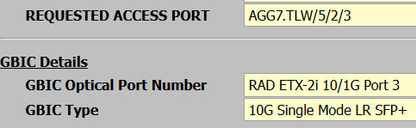

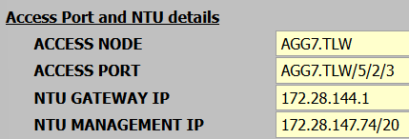

NTU GATEWAY IP: 172.28.144.1
NTU MANAGEMENT IP: 172.28.147.74/20

ETX-2i 10G Dual power DCR

-----------------------------------------------------
WSA7021672
ESB Tullow - EMRAN

AGG7.TLW 5/2/3

ODF7.TLW 1/1/128 TX

12 Fibre to ESB Sub Station
Port 10

